OS HW 2: Prithul Sarker

Problem 1

Man page of free command:

In my computer free-o command does not work so I have done the same task using only free command.

Execution of free command:

Executing free command 10 times at a constant time interval (10 seconds) running other programs in between:

I used free command on an interval of 10 sec. So for the per unit time measurement, the memory used, buffered/cached and swap used are divided by 10 sec. In the above diagram, we can see that the memory used per unit time increases with the memory being used. However, swap memory could only be used when the main memory is full. So, the swap memory is zero for the figure. Again, at first, buffer is being used more than the memory used. For this reason, the (memory used -memory buffered – memory cached) per unit time values are in negative region. However, after few 10 second intervals, the buffer memory does not increase in the similar way compared to the memory used. This is why, (memory used -memory buffered – memory cached) per unit time is in the positive region.

Problem 2

For .exe files, the mean and median of the files are 4617.24 and 73 Kb respectively.

And optimal page size = (2\* s \* e)1/2

Here, e = 8 bytes, and s = pages per process \* page number = 28 \* 4617.24 \* 1024

Therefore, optimal page size = (2 \* 28 \* 4617.24 \* 1024 \* 8)1/2 = 139162 bytes

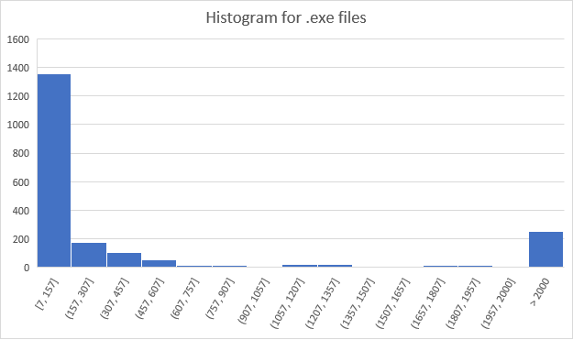

For .dll files, the mean and median of the files are 31121.72 and 35.375 Kb respectively.

And optimal page size = (2\* s \* e)1/2

Here, e = 8 bytes, and s = pages per process \* page number = 28 \* 31121.72 \* 1024

Therefore, optimal page size = (2 \* 28 \* 31121.72 \* 1024 \* 8)1/2 = 361294.83 bytes

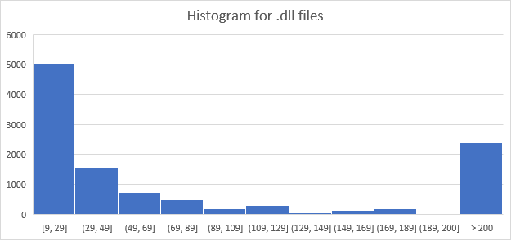

The text files containing all the .exe and .dll file names and sizes are uploaded separately inside the zip file.

Problem 3

Man page of df command:

Execution of df Command:

The underlined numbers under “Available” column are the available disk sizes of the file system. The other non-underlined disk sizes are already 100 % used.

Execution of df-i command:

In the above diagram the total number of I nodes are shown under the column of Inodes. The underlined numbers under the ‘Ifree’ colume are the Inodes which are available, the used I nodes are shown under the Iused column.

df and df-I command execution after creating a new file with just a few characters in it:

Changes in available disk space are underlined in df command after few characters.

df and df-I command execution after an increasing character size over 5000:

Changes in available disk space is underlined in df and df-I command after increasing the number of characters to over 5000.

Problem 4

Output of the code

The c code file is uploaded in the zip file.